FRONTEND DEVELOPMENT ASSIGNMENT
Single Screw Extruder
Production-Grade Industrial Monitoring UI
Build a modern frontend dashboard and interactive machine canvas using simulated data.
Frontend only  No backend, database, API or IoT integration required. | Simulated data  Generate realistic machine values on the frontend. | Public deployment  Deploy the final UI to Vercel, Render, Netlify or similar.

Task Overview
Build a production-grade frontend web application for an industrial machine called Single Screw Extruder. The assignment has two primary UI deliverables: (1) a modern performance dashboard and (2) an interactive Single Screw Extruder machine canvas/template.
The three reference images below explain the intended concept. They are provided as reference/inspiration only. The final implementation should improve upon the references and should not simply reproduce them.

Reference Images
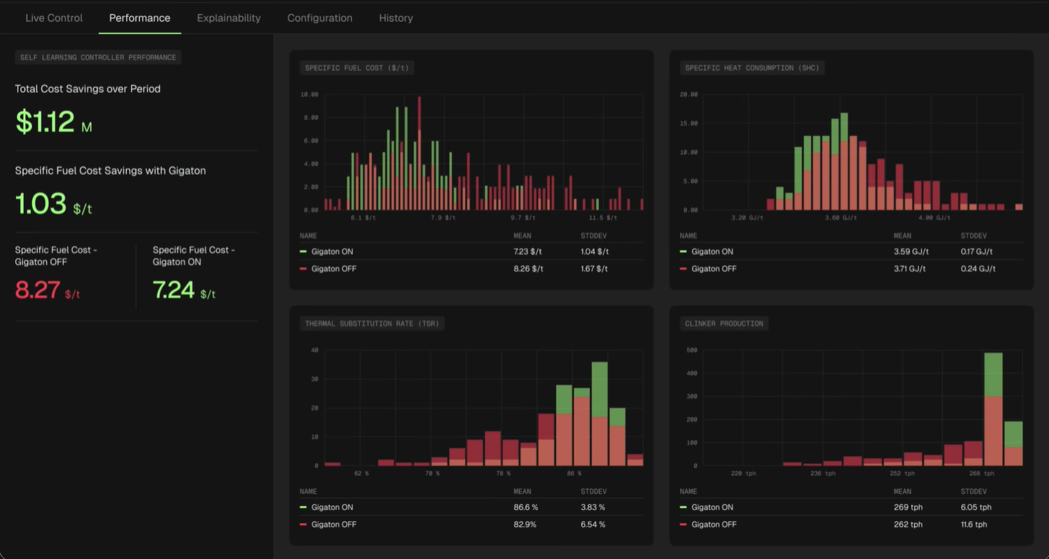
Image 1 — Performance Dashboard: Reference for the dashboard structure, metrics and data visualization.

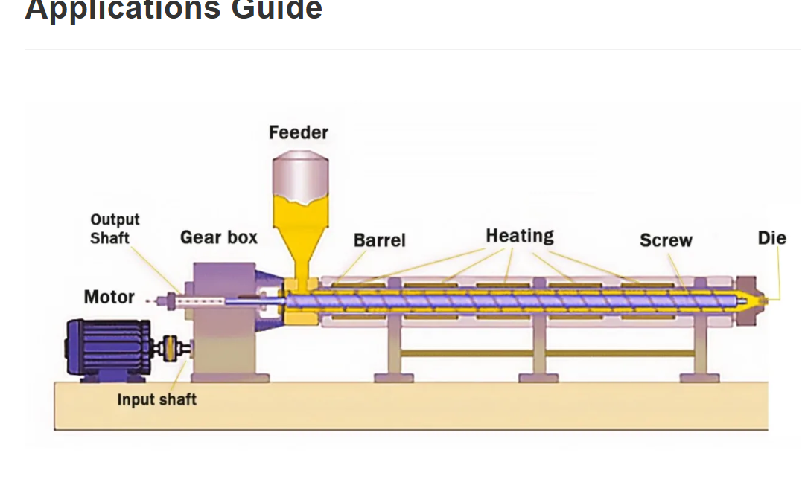
Image 2 — Single Screw Extruder: Source/reference image that must be converted/recreated as an interactive machine canvas.

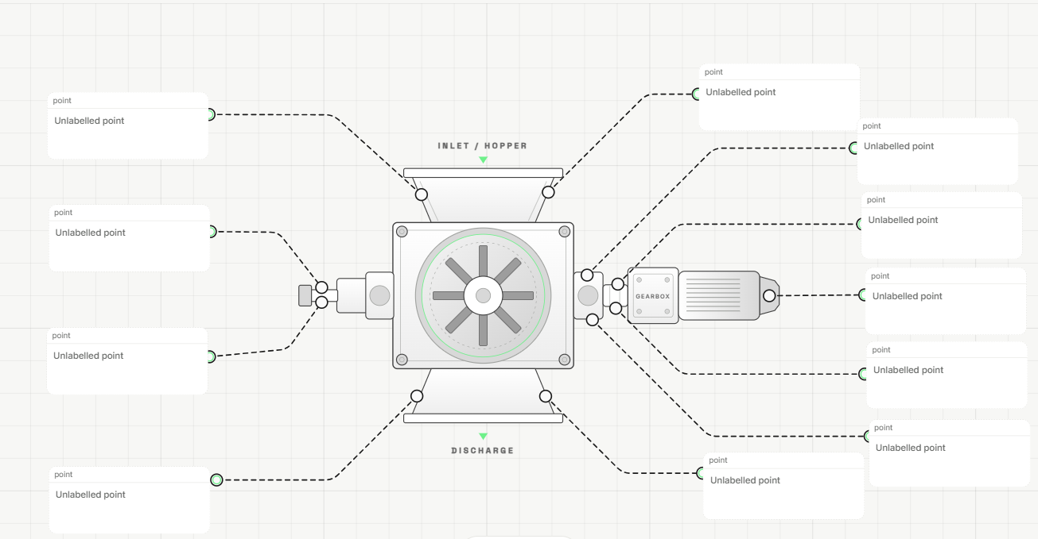
Image 3 — RAV Canvas Template: Reference for the interactive machine canvas, connection points and simulated data visualization.

1. Dashboard Page
Create a modern, polished Single Screw Extruder dashboard using Image 1 as the primary reference for the type of information and visualization required.
The dashboard should include relevant simulated parameters such as:
- Machine Status
- Screw Speed / RPM
- Barrel Temperature
- Die Temperature
- Melt Pressure
- Motor Power
- Torque
- Throughput
- Feed Rate
- Energy Consumption
- Production / Performance metrics
- Alerts and warnings
- Historical trends and charts
The dashboard should have a significantly more refined, modern and production-grade UI than the reference image. Focus on clear information hierarchy, excellent spacing, typography, responsive design and useful data visualization.

2. Single Screw Extruder Machine Canvas
This is the main part of the assignment.
Use Image 2 (Single Screw Extruder) as the source/reference for creating the machine visualization. The candidate must convert/recreate the Single Screw Extruder image into an interactive canvas template similar to Image 3 (RAV Canvas Template).
The final canvas should:
- Represent the Single Screw Extruder visually.
- Identify the important components/parts of the machine.
- Have clearly defined connection/measurement points associated with relevant components.
- Display simulated sensor values connected to those points.
- Show relevant data when interacting with or hovering over machine components/measurement points.
- Visually communicate the current machine operating condition.
- Follow the concept and interaction pattern of the existing RAV canvas.
- Be designed as a reusable template for other Single Screw Extruder machines.

Suggested Machine Data Mapping
Machine Component | Example Simulated Data
Feeder / Hopper | Feed Rate
Motor | Motor Power / RPM
Gearbox | Torque / Speed
Barrel | Zone Temperatures
Screw | Screw Speed
Heating Zones | Temperature
Die | Die Temperature / Pressure
Output / Discharge | Throughput
The above mapping is only a guideline. Candidates may determine additional or different measurement points based on the Single Screw Extruder reference image.

3. Simulated Machine Data
No backend, database, API, authentication, or real IoT integration is required. All machine values should be simulated on the frontend and connected to the appropriate points on the canvas.
Values should preferably change dynamically so that the application feels like a live industrial monitoring system.
Screw Speed 145 RPM
Barrel Temperature 182 °C
Melt Pressure 126 bar
Motor Power 74 kW
Throughput 428 kg/hr
Torque 68%
Machine Status Running

4. Animations & Interactions
Add minimal and professional animations to make the machine visualization feel live.
- Motor/screw rotation
- Material flow
- Live sensor indicators
- Temperature changes
- Dynamic sensor values
- Machine status changes
- Hover/click interactions
- Smooth chart updates
Animations should be subtle and should improve the overall user experience without making the interface unnecessarily complex.

5. Production-Grade UI
The complete application should demonstrate strong frontend and UI/UX skills, with focus on:
- Modern industrial UI
- Clean and minimal design
- Excellent spacing and typography
- Responsive layout
- Reusable components
- Interactive machine canvas
- Data visualization
- Smooth interactions
- Accessibility
- Performance
- Consistent design system
- Production-quality code
The candidate is expected to improve upon the provided references rather than reproduce them exactly.

6. Deployment
Deploy the completed frontend application publicly using Vercel, Render, Netlify, or any other suitable deployment platform. The deployed application must be accessible through a public URL.

7. Submission
Please reply to this email with:
- Live deployed application URL
- GitHub repository URL
- Brief explanation of your approach
- Technologies/libraries used
- Any additional features you implemented

End of Assignment

